- UNIFIED DATA EXCHANGE (UDX)
  - Strategic Context
Data is a critical foundation for the Bank’s AI transformation. Effective AI adoption requires reliable, accessible and governed information that can be reused across business functions.
The Bank has established data capabilities, including the Data Management Solution (DMS), distributed data marts, integration capabilities, Alteryx and business intelligence tools. These investments provide a foundation that can be further integrated and optimised to support enterprise-wide data consumption.
UDX is proposed through the enhancement and integration of these existing capabilities, establishing a common data foundation for applications, reporting, analytics and AI. Within the proposed enterprise architecture, UDX will provide trusted data, while shared AI services will enable machine learning and generative AI capabilities.
  - Enterprise Data Infrastructure through UDX

UDX aims to establish a governed and reusable enterprise data infrastructure that enables authorised applications, analytics and AI solutions to securely access and use trusted data across the Bank.

The proposed scope as per followings:
Strategic Focus | Proposed Approach
Optimise existing investments | Leverage DMS, databases, distributed data marts, integration capabilities and analytics tools, including Alteryx, OBIEE, Tableau and Power BI, according to their suitability.
Integrate and prepare data | Establish pipelines to ingest, standardise, validate and refresh information from databases, files and APIs.
Provide reusable data products | Maintain governed consolidated datasets, historical information and purpose-specific data marts for multiple business requirements.
Enable controlled consumption | Provide authorised access through APIs and other controlled interfaces for applications, dashboards, analytics and AI services.
Apply enterprise governance | Operate in accordance with the BPMB Data Governance and Management Framework, including ownership, guardrails, quality, metadata, lineage, access and security requirements.

UDX will establish a shared enterprise data foundation that maximises existing investments, reduces repeated integration efforts and supports progressive deployment of AI and digital capabilities beyond SIH.

  - Prioritize use case – SME Intelligence Hub (SIH)

    - Objective

To establish an integrated SME intelligence and advisory capability that enables SME Development Services (SDS):
- Understand each SME’s relationship with the Bank
- Identify development needs
- Prioritise engagement and
- Coordinate interventions towards improved business and financing outcomes.

    - Proposed SDS SME Development Lifecycle
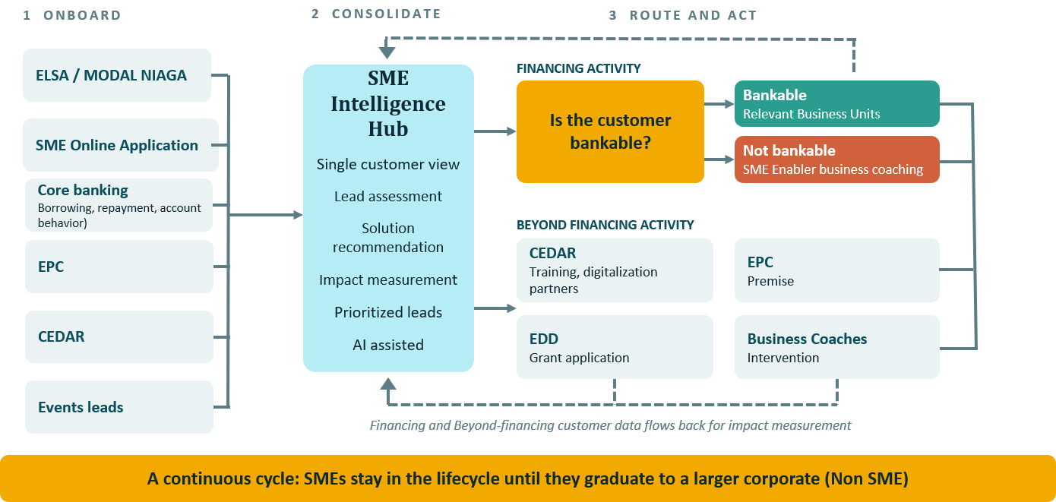
SDS proposes a continuous SME development lifecycle, from onboarding and engagement through to business growth and eventual graduation into a larger enterprise.
Supported by the SME Intelligence Hub (SIH), SDS will act as the central coordinator of financing and Beyond Financing interventions.
The proposed lifecycle ensures that engagement continues when an SME is not immediately eligible for financing.
- SDS will coordinate the support needed to address business gaps and
- Facilitate reassessment when the SME’s circumstances improve.
This approach will strengthen mandate delivery, improve management reporting, reduce manual data consolidation and provide a more consistent view of SME relationships. It will also enable the Bank to track whether developmental support is followed by improved business and financing outcomes, providing a basis for evaluating intervention effectiveness.

    - Business Requirement and Initial Data Scope

The initial scope of SIH cover approximately 100k++ reported records across SQL databases and excel files, spanning financing and beyond financing activities
Structure Data Coverage | Information to Be Connected | Estimated volume
Business profiles and assessments | ELSA/Modal Niaga profiles, lifecycle assessments, improvement priorities and financing referrals. | ELSA current user profiles estimate at 6,000.
Financing relationships | Profiles, applications, financing, outcomes, repayment and behaviour from the relevant financing system | Active financing customer approx. 6,000
Beyond Financing engagement | CEDAR/CBRS profiles, training and coaching, EPC tenancy, event participation and related developmental activities. | Most data contributed by CEDAR approx. 80k SMEs, followed by engagement through events, EPC and other services

The records may include the same SME across several sources and do not represent 100k unique SMEs. Source update frequencies vary from daily to monthly and quarterly.

Currently, information is fragmented across these systems. This limits visibility of the SME’s overall relationship with the Bank, the support it has received and its subsequent progress.

SIH will connect these records through a common SME identifier. The SME Unified Records will establish a consistent identity, while linked assessments, engagements and financing history will form the SME 360° view.

SIH will also require access to approved documents and institutional knowledge to support AI-assisted insights and recommendations.
Unstructured Data Coverage | Information to Be Connected | Estimated size
Product, programme and process knowledge | Financing product sheets, programme and service criteria, process manuals, referral procedures and advisory guidance. | Document volume and storage needs will be confirmed with business owners. A 20 MB per-file upload limit is proposed, subject to validation, with larger files handled separately.

SIH will leverage AI Knowledge Hub using Retrieval Augmented Generation (RAG) to retrieve approved product, programme and process information, supporting source-based insights and proposed interventions for SDS review.

    - Proposed SIH Capabilities
Capability | Technology Enabler | Business Application
SME 360° view | UDX / Integrated data products | Consolidate profiles, assessments, engagement touchpoints, financing and developmental history.
ML-driven lead generation | Machine learning | Identify and prioritise SMEs for outreach using business profiles, engagement signals and historical outcomes.
AI-assisted advisory | Generative AI / Knowledge Hub (RAG) | Combine SME records with approved knowledge to explain improvement needs and propose actions for SDS review,
Solution matching | Business rules / Knowledge Hub (RAG) | Identify relevant financing products, training, coaching and other developmental support for further consideration.
Portfolio and impact reporting | Business intelligence / Analytics | Monitor engagement, intervention needs, financing progression and developmental outcomes.
Formal bankability assessments and financing decisions will remain with the authorised business and credit functions under established processes. Similarly, eligibility assessments and onboarding decisions for Beyond Financing programmes and services will remain with the respective programme or service owners.

    - Illustrative Of SIH Solutions and Capability Concepts

      - SME Unified Records data view
The following illustrates selected fields from a proposed consolidated SQL view, udx.vw_sme_360.

Fictional data for illustration.
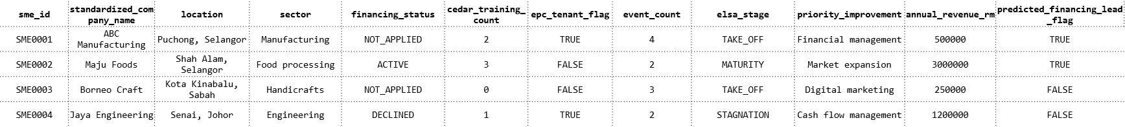

Information previously held separately is consolidated against the same SME. Underlying source records, activity dates and historical outcomes will remain available for traceability and journey tracking.

The predicted financing lead indicator is a derived by machine learning (ML) output for engagement prioritisation. It does not constitute a bankability assessment or financing approval.

      - Retrieval Augmented Generation (RAG) / Knowledge Hub
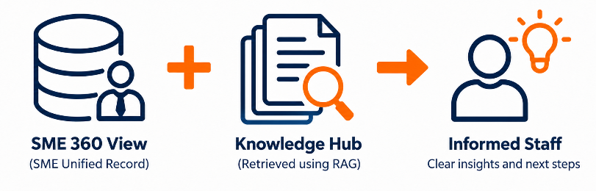
To assist SDS officer spend less time searching and can make better-informed referrals using SME information and approved guidance, with sources available for verification.

RAG / Knowledge Hub illustrated backend overview

SQL Metadata Storage | Object Storage | Vector / Search Index
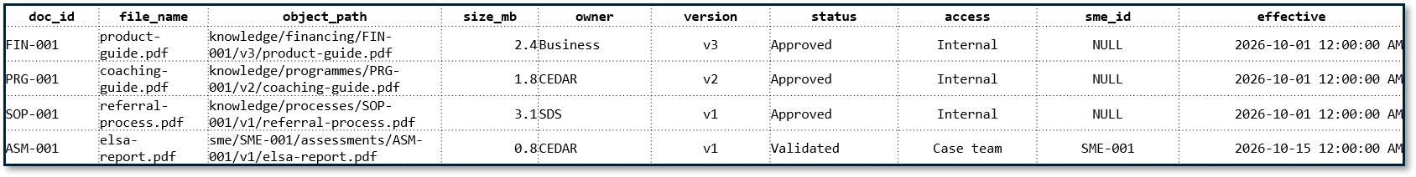 | 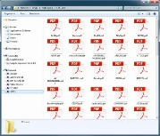 | 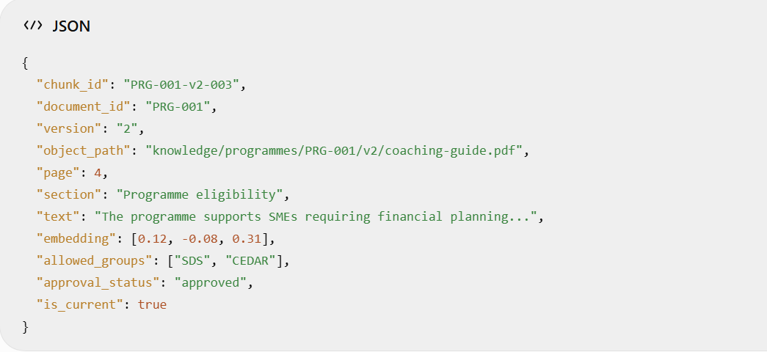

      - Business Intelligence (BI) Dashboard
To improve SME financing conversion and developmental outcomes through targeted engagement, timely interventions and effective resource allocation, supported by consolidated SME intelligence, including impact reporting.

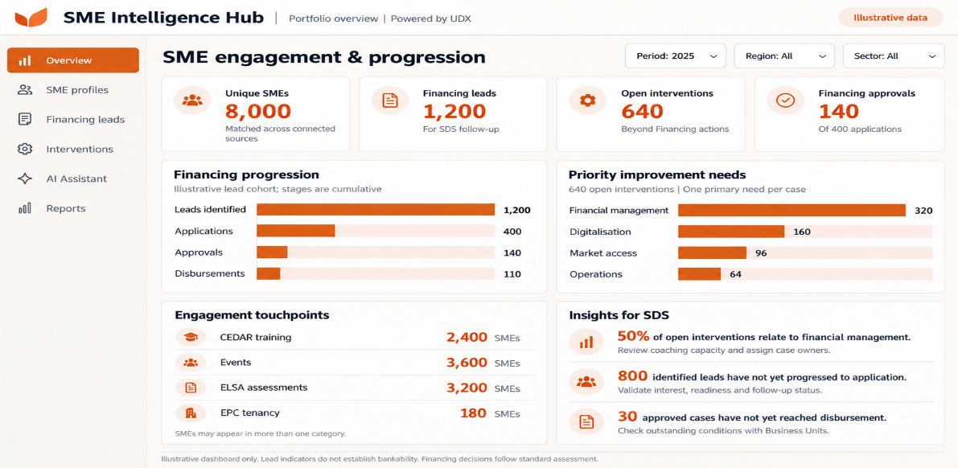

      - AI-conversational assistant
Enable authorised SDS officer to make faster, better-informed engagement and intervention decisions by using AI to consolidate available SME records into clear insights and recommended next actions, reducing time spent searching across systems.

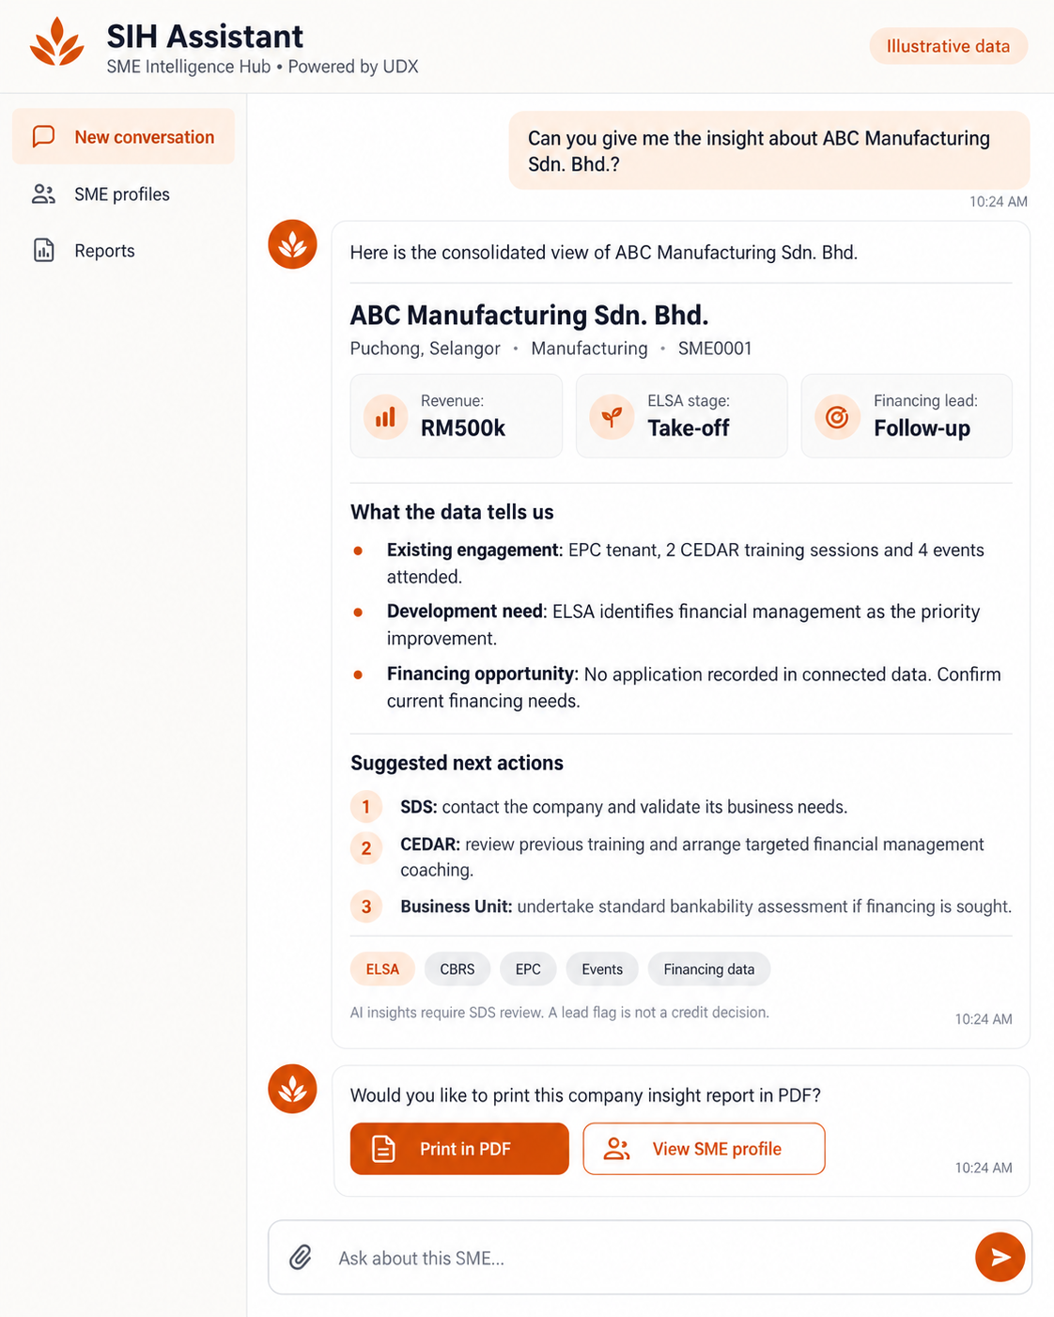

      - SME Insight Report
Support consistent, well-informed SDS engagement, referrals and case discussions through a printable company insight report that brings together the company profile, key insights, improvement priorities and proposed actions.

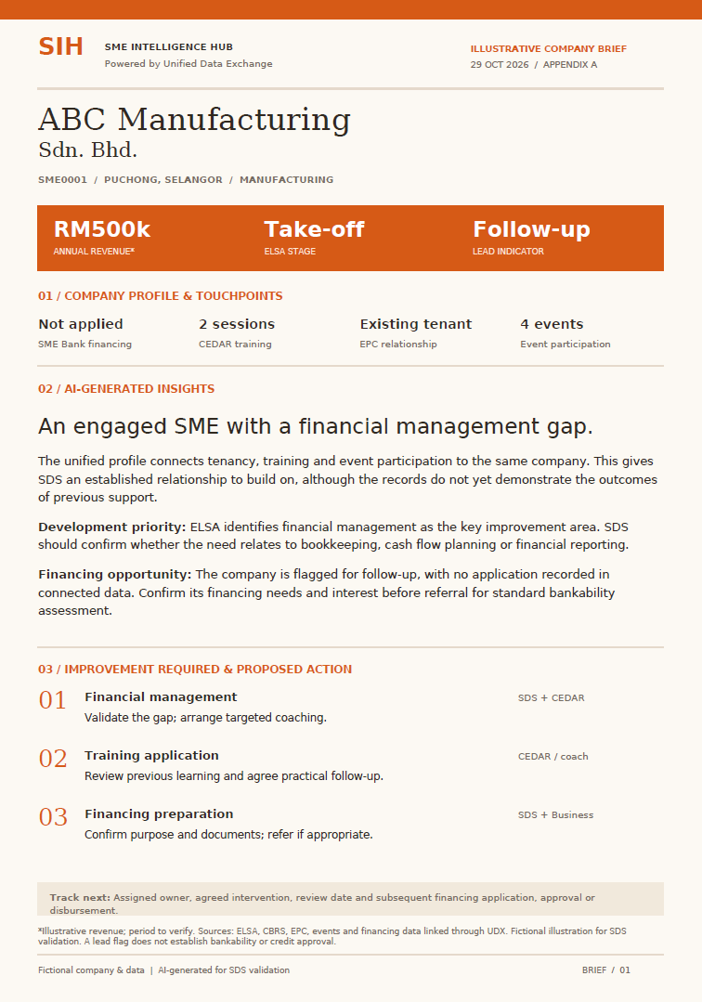

    - Proposed Implementation Approach and Timeline
The development of SME Intelligence Hub timeline estimated 6 months, where critical resources are SDS as project lead, IT is including innovation, data and infra. The control function is to ensure project compliance especially to newly approved AI policy and existing data governance.
Project Name | Implementation focus | Key deliverables | Indicative timeline | Working Team
SME Intelligence Hub (SIH)  Data Foundation and AI-Enabled SME Intelligence | Integrate priority datasets, improve data quality and match SME identities. Develop BI reporting, ML lead prioritisation and GenAI insights. | - SME Unified Record,  - Prioritised leads  - BI dashboard  - AP conversational assistant | Estimated 6 – 8 months from project commencement | - SDS – Lead  - IT Innovation, Data, Infra  - Control function

The complete suite of SME Intelligence Hub will extend to another phase focusing on the development of integrated operational applications and workflow to coordinate case management and tracking of developmental and financing outcomes.

